VSCODE

Install ES Lint and Material Theme Icon and Path Intellisense and Prettier – Code Formatter

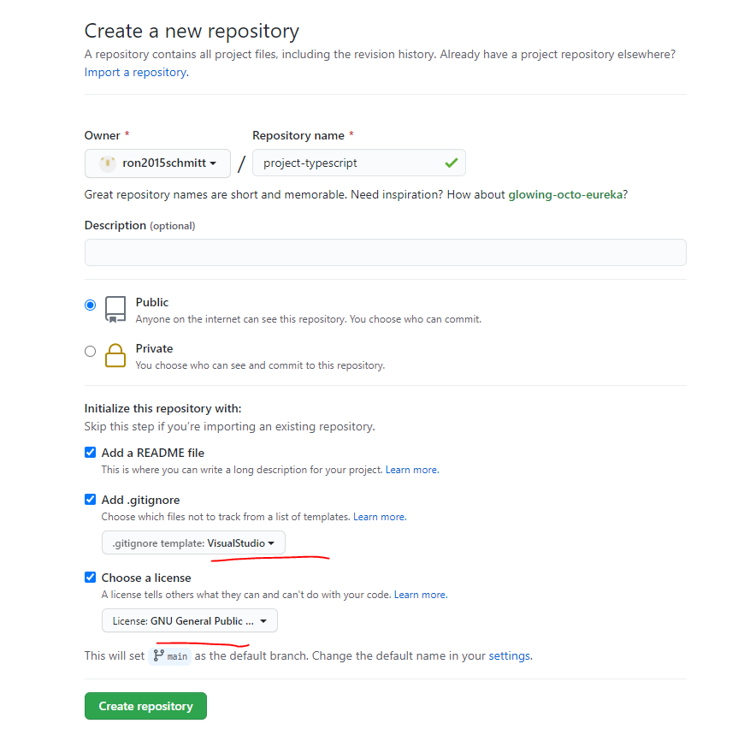

git clone https://github.com/ron2015schmitt/project-typescript.git

cd project-typescript/

copy the following course files from F:\ron-online-classes\Understanding Typescript\course-starting-project into this folder



open this folder in VSCOde

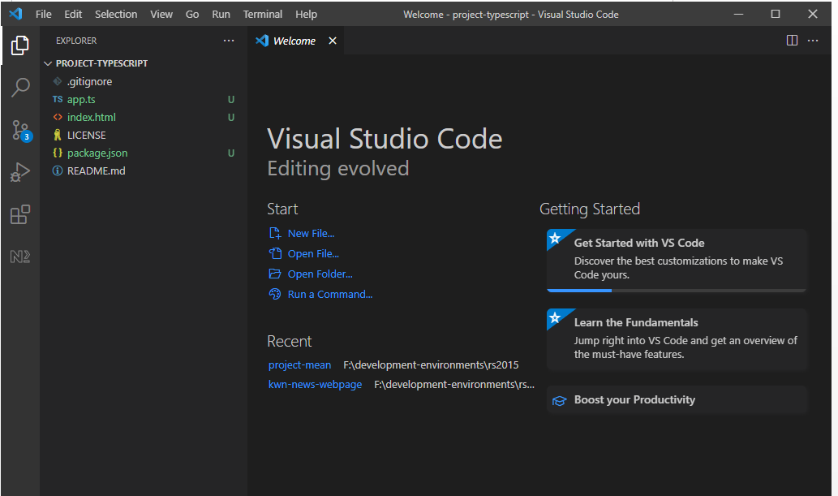

Commit and push via vscode or git bash

**Updated through chap 10**